LIVINGSTON FIRE DEPARTMENT
100TH Anniversary Celebration
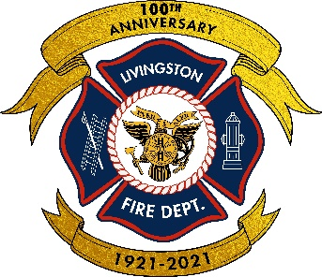
Saturday October 1, 2022
(Rain Date October 8, 2022)
To Our Friends in the Livingston Community,
As you are likely aware, the Livingston Volunteer Fire Department is celebrating our 100th Anniversary this year. For an entire century, the members of the Livingston Fire Department have volunteered to provide protection to the community. As part of this celebration, we are currently planning a large community event to be held on Saturday October 1, 2022, at the Memorial Park Oval.
The day-long event will feature a fire apparatus parade from Livingston Center to the Oval with modern and antique apparatus on display. Following the parade there will be judging of the fire trucks in various categories with trophies issued to the winners. Simultaneous to the truck show, we will be hosting our annual Fire Prevention Open House, usually held at Fire Headquarters, to include fire prevention demonstrations and programs, food, music, historic displays, beer garden, as well as games and exciting activities for kids and adults alike.
Following the daytime events, we will step back in time by hosting a nostalgic evening “Block Dance”. The Fire Department Block Dance was held annually from 1955 to 1979 and attracted thousands of visitors each year. We will be re-creating the Block Dance atmosphere just as it was back then with live music, line dancing, square dancing, vintage outfits, food, displays, carnival games, and many raffles and prizes.
We do not normally solicit support from the business community but are asking for financial or other sponsorships to make this once in a lifetime celebration a huge success for the entire Township of Livingston. Participating sponsors will be recognized so everyone in attendance is aware of the support.
We look forward to hearing from you and seeing you all at the events on October 1st!

LIVINGSTON FIRE DEPARTMENT
100TH Anniversary Celebration
Sponsorship Form

Business: _________________________________________________________
Contact Name: _____________________________________________________
Phone Number: ______________ Email Address: _________________________
Address: _________________________________
_________________________________
Sponsor Levels: Names to be displayed on sign boards at event
- $50 Bronze
- $150 Silver
- $300 Gold
- $500+ Platinum
Game/Gift Sponsors: Names to be displayed at area of support
- Toy prizes for children at game booths
- Donation of food, beverages for events (can be monetary or physical donation)
- Raffle Prizes for Fire Prevention Event (will include toy fire trucks, etc.)
- Raffle Prizes for Block Dance (will include various household items to mimic yesteryear events)
- Truck Show Trophies
Please contact us if you can assist at LFD100th@gmail.com or contact Jim Kedrie at 973-223-4458. Please forward form and checks made out to Livingston Fire Department

We sincerely thank you in advance for any support of this community event

Livingston Fire Department, 62 South Livingston Avenue, Livingston, New Jersey 07039

