LIVINGSTON FIRE DEPARTMENT
100TH Anniversary Celebration
Parade and Apparatus Muster
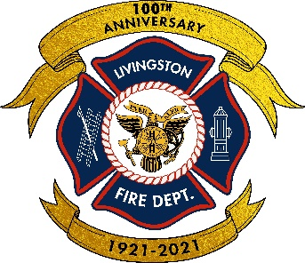
Saturday October 1, 2022
(Rain Date Saturday October 8, 2022)
Please join us in celebrating 100 years of volunteer service
with an apparatus parade and muster
Parade will begin at 10:00 AM…Route to be announced but will proceed to Memorial Park Oval in front of Livingston High School…Muster with trophies and awards to follow
Food and community activities all day
All apparatus, antique and current, welcome to participate in parade and judging
Exciting evening events also planned with food and beverages, live band, beer garden, raffles, and prizes
Please respond to LFD100th@gmail.com for a registration form and to receive details on the event as they are finalized
Please feel free to forward/distribute

